**MH 60 Airfoil (UAV) Glider**

For a SIGINT Drone its main purpose is to be able to *glide* either through an initial thruster (as seen with Kamikaze drones) or thrown into the sky.

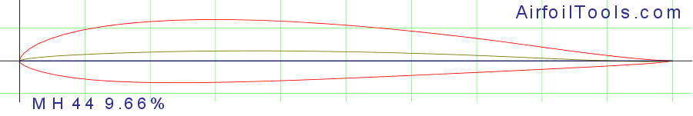

According to this image we can see the upper and lower surface of the MH60-il. This design is used for the wings of a plane. The MH60-il is a symmetrical airfoil meaning both the top and bottom surface are identical, which in this case means the chamber and chord line are the same. This also means due to equal air pressure on both the top and bottom, this means that at a zero-angle attack line (straight path) this plane is unable to increase its lift, meaning any attack line that is greater than 0 will allow for the glider to increase its lift.

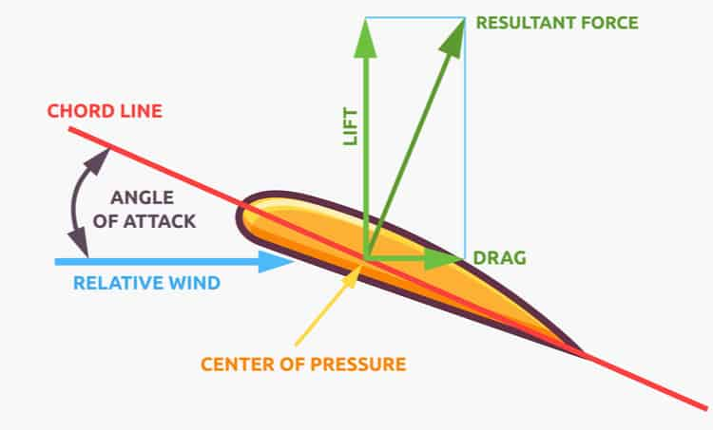

Comparatively to an asymmetrical airfoil, this has a decrease in lift, but in our project’s case this does not matter as the functionality of the drone matters, with a UAV style drone the importance of a simple design and stable center allows the UAV to be predictable.

**Graphs of Performance**

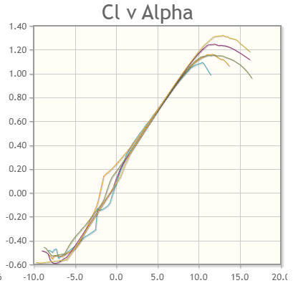

*Cl (Lift Coefficient) vs Angle of Attack (Alpha)*

As we can see from this graph the MH60 has a curve around 1.2-1.4 Cl at ~10-13 Alpha. Knowing that Cl measures lift from the airfoil and Alpha are the tilt angle of the wing into the wind, we can see that at low speeds and shallow angles (less than 45 degrees), this creates an excellent lift

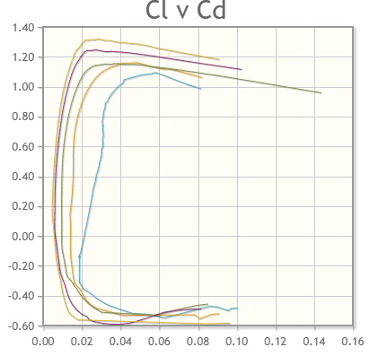

*CD (Drag Coefficient) vs Lift Coefficient (Cl)*

Drag Coefficient is the ability to measure the amount of drag (or resistance) comes onto the airfoil, with the lower Cd indicating a more efficient airfoil. As we can see from the graph, the MH60-il maintains a 0.2-0.4 CD with a Cl of 1.2-1.4 this means that the drag at their respective lifts is low and allows the airfoil to glide for a much longer period. For SIGINT UAV this is crucial for having enough time to capture packets for as long as possible.

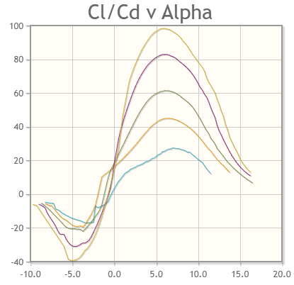

*Lift-to-Drag Ratio (Efficiency)*

This graph illustrates how far a glider can glide before its altitude begins to sip, the higher the y-axis is the better it will be. In this case once the Alpha reached a little over 5.0 the height begins to decrease slowly dipping due to the low CD.

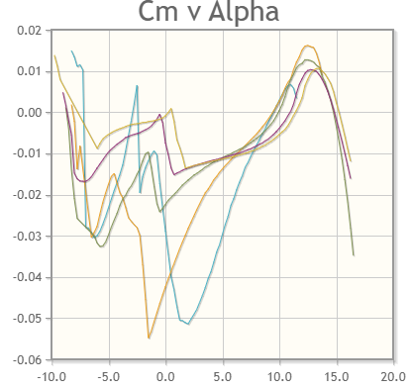

*Cm (nose pitch) vs Alpha*

As the Alpha increases the Cm increases with it, this means that at a higher angle tilt between the wing and the wind, the glider is still stable and does not have any turbulence when flying.